Galderma Monthly PTR Staging Area

User Documentation
Version 1.0


Contents
1 Document control 3
1.1 About this document 3
1.2 Changes made to this document 3
1.3 Purpose of this document 3
1.4 Audience for this document 3
2 Assumptions and constraints 4
3 Input Data 5
3.1 Process steps 6
4 QC 8
5 Appendices 16
5.1 Appendix A1: Download FTP Information 16
5.2 Appendix A2: Download Server Information 16
5.3 Appendix A3: Processing Server Information 16
5.4 Appendix A4: File Express Information 16

Document control

About this document
Author | Anika Nower
Published
File location
Status
Confidentiality | This document is confidential and must not be distributed outside of IMS Health.
Copyright | © 2026 IMS Health Incorporated or its affiliates. All rights reserved.

Changes made to this document

Version | Sections changed or created | Date of change | Author or contributor name | Role | Change summary
 |  | August, 12 | Anika Nower

Purpose of this document
The purpose of this document is to describe Galderma Monthly PTR Staging area.

Audience for this document
This document has been written for:
- Production team members

Assumptions and constraints

ID | Assumptions

ID | Constraints

Input Data
Sample mail
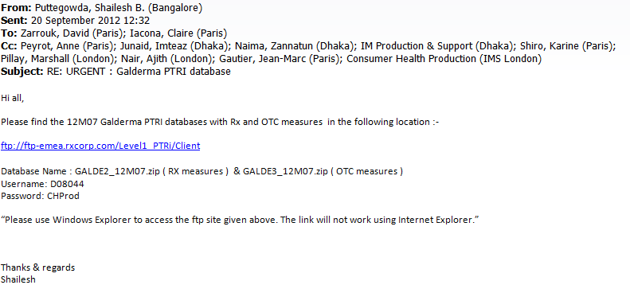
Log in to filezilla using Credential at Appendix A1

3.1 Process steps
Step | Action
1 | Log on to the server using Appendix A3
2 | Download the zip file to the following location:  D:\CustomData\Galderma_midas_feed\Input\Monthly\Monthly PTR\
3 | Unzip file using Extract to zipfile name.  [For example: GALDER_12M05.zip as GALDER_12M05]  [For example: GALDER2_12M05.zip as GALDER2_12M05]  [For example: GALDER3_12M05.zip as GALDER3_12M05]
4 | Rename the unzip folder M01,M02,M03.  [For example: GALDER_12M05 as M01]  [For example: GALDER2_12M05 as M02]  [For example: GALDER3_12M05 as M03]
5 | Go to: D:\CustomData\Galderma_midas_feed\Tools\windump
6 | Run Windump32.exe see the screen short below:  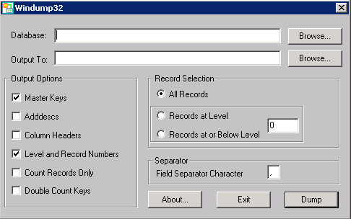
7 | Browse Database  D:\CustomData\Galderma_midas_feed\Input\Monthly\Monthly PTR\M01\.PRM  Browse Output To: D:\CustomData\Galderma_midas_feed\Input\Monthly\Monthly PTR\M01\M01.txt  Check Master Keys , Column Headers  Select records at level 14(must check :less one from attribute, after checking .prm file using system utilities)  Separator ‘|’  Click Dump
8 | Repeat step 5-7 for M02, M03
Note: Header sequence must be
CTY|CRP|MNF|MOL|INTPRD|PRD|PCK|PCK-DATE|PRD-AGE|OTC3|OTC4|NFC123|PRES|REG|STR|
9 | Go to:  D:\CustomData\Galderma_midas_feed\SSIS\galderma_midas_feed_PTR_OTC_RX
10 | Open galderma_midas_feed.sln
11 | Run Galderma_Monthly_PTR.dtsx package
12 | Output file IMS_GALDERMA_PTR_FF_Mmmyy_CR.txt will generate on following location:  D:\CustomData\Galderma_midas_feed\Output\Monthly\PTR_MONTHLY
13 | Rename the file with latest time period.  [for example IMS_GALDERMA_PTR_FF_Mmmyy_CR.txt as IMS_GALDERMA_PTR_FF_M0512_CR.txt]  Note: The sequence of the headers, text qualifier and delimiter should be exactly like this:  "COUNTRY";"CORPORATION";"MANUFACTURER";"MOLECULE";"INTERNATIONAL PRODUCT";"PRODUCT";"PACK";"PACK DATE";"PRODUCT AGE";"OTC3";"OTC4";"NFC123";"PRESCRIPTION INDICATOR";"REGISTRATION";"STRENGTH";"PERIOD";"SALES-CU";"SALES-SU";"SALES-UN";"SALES-PUB-USD";"SALES-PUB-LCD";"SALES-PUB-EUR";"SALES-PUB-LCE";"AvPrice-PUB-USD";"AvPrice-PUB-LCD";"AvPrice-PUB-EUR";"AvPrice-PUB-LCE";"RX-SALES-CU";"RX-SALES-SU";"RX-SALES-UN";"SALES-PUB-USD(RX)";"SALES-PUB-LCD(RX)";"SALES-PUB-EUR(RX)";"SALES-PUB-LCE(RX)";"AvPrice-PUB-USD(Rx)";"AvPrice-PUB-LCD(Rx)";"AvPrice-PUB-EUR(Rx)";"AvPrice-PUB-LCE(Rx)";"OTC-SALES-CU";"OTC-SALES-SU";"OTC-SALES-UN";"SALES-PUB-USD(OTC)";"SALES-PUB-LCD(OTC)";"SALES-PUB-EUR(OTC)";"SALES-PUB-LCE(OTC)";"AvPrice-PUB-USD(OTC)";"AvPrice-PUB-LCD(OTC)";"AvPrice-PUB-EUR(OTC)";"AvPrice-PUB-LCE(OTC)"
14 | Zip the txt file  [for example IMS_GALDERMA_PTR_FF_ M0512_CR.txt as IMS_GALDERMA_PTR_FF_M0512_CR.zip]
15 | Backup the txt and zip file in one folder with name the latest period.
16 | For delivery:  Log in to server using Appendix A4 to Appendix A2
17 | Copy the file from \\162.44.22.161\d$  Select Favorite Products →IMS File Express Administration → Add new file→browse select the output zip file and QC file.  Template :Galderma  File description: Monthly PTR delivery for Mmm/YY MIDAS Monthly data  Save all.
18 | Go to D:\CustomData\Galderma_midas_feed\Output\Monthly\PTR_MONTHLY\Old  Create a New folder named MmmYYYY  [For example, the folder name M042012]
19 | Take backup of the files in D:\CustomData\Galderma_midas_feed\Input\Monthly\Monthly PTR\  To the newly created MmmYYYY folder.

QC
1 | Go to: D:\CustomData\Galderma_midas_feed\Input\Monthly\Monthly PTR\M03  Edit .prm file with three changes:  1. add all average measure sequentially as  excel file: Galderma - IMS PTR Data Feed File Specification v3  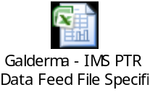  sheet: DataElements and Measures  0 AvPriceUSDPUB "AvPrice-PUB-USD(OTC)" 8 N Y N 0 0 0 CLASS CALC 5 1 /  0 AvPriceLCDPUB "AvPrice-PUB-LCD(OTC)" 9 N Y N 0 0 0 CLASS CALC 4 1 /  0 AvPriceEUROPUB "AvPrice-PUB-EUR(OTC)" 10 N Y N 0 0 0 CLASS CALC 6 1 /  0 AvPriceLCEPUB "AvPrice-PUB-LCE(OTC)" 11 N Y N 0 0 0 CLASS CALC 7 1 /  For example:  AvPrice-PUB-USD(OTC)=5 1 /  Reason: OTC-SALES-OUT(USD) 5  OTC-SALES-OUT(UN) 1  Logic: AvPrice-PUB-USD(OTC) is calculated by OTC-SALES-OUT(USD) divided by OTC-SALES-OUT(UN)  Same procedure for other Three average measure.  - @VARIABLE_DETAIL 8 replace by @VARIABLE_DETAIL 12  - @NUMBER_FORMAT 7 replace by @NUMBER_FORMAT 11  - Add these four lines below @NUMBER_FORMAT 11  1 12 0  1 12 0  1 12 0  1 12 0  Same procedure for M02 and M01, and these two .prm file measure position will be change.
2 | Open the .prm file with the following dvf files from:  D:\CustomData\Galderma_midas_feed\Input\Monthly\Monthly PTR\DVF\M01  D:\CustomData\Galderma_midas_feed\Input\Monthly\Monthly PTR\DVF\M02  D:\CustomData\Galderma_midas_feed\Input\Monthly\Monthly PTR\DVF\M03  Copy the data country wise into:  PTR_Test.xls at D:\CustomData\Galderma_midas_feed\Input\Monthly\Monthly PTR
3 | From PTR_Test.xls copy the data records set without header and paste into  IMS_GALDERMA_PTR_FF_VALIDATION_Mmmyy.XLS in  Sheet: MTH  Segment:dataview  at D:\CustomData\Galderma_midas_feed\Input\Monthly\Monthly PTR\
4 | Now log on to SQL Server 2005  Server Name : PLYSSQL232P
5 | Run PTR_OTC_RX_MTH_QA.sql  from D:\CustomData\Galderma_midas_feed\Tools\SQL
6 | Paste result into MTH sheet in Output segment after Header.  After Paste, all [AvPrice-PUB-***] will be blank.  All [AvPrice-PUB-***] will come from Dataview segment’s [AvPrice-PUB-***].  (assumed [AvPrice-PUB-***] are already rounded.)
7 | Check DIFF page that Diff should be 0.0000%.  Sometimes it can vary. That time we will analysis, that the specific data which varies, in output and dataview section, the corresponding cell is smaller range (less than 6 digit) or not. If yes then it is considerable. If not, then back to analysis more in dataview and output.
8 | Markets Sheet contains the market definition based on OTC selection which usually client provides. This sheet always attached and remain same with QC file until get any notification from client.
9 | Again  Open the .prm file with the following dvf files from:  D:\CustomData\Galderma_midas_feed\Input\Monthly\Monthly PTR\DVF\M01  D:\CustomData\Galderma_midas_feed\Input\Monthly\Monthly PTR\DVF\M02  D:\CustomData\Galderma_midas_feed\Input\Monthly\Monthly PTR\DVF\M03  Change Period tab from month1 to MAT1  Copy the data country wise into:  PTR_Test.xls at D:\CustomData\Galderma_midas_feed\Input\Monthly\Monthly PTR
10 | From PTR_Test.xls copy the dataview records set without header and paste into  IMS_GALDERMA_PTR_FF_VALIDATION_Mmmyy.XLS in  Sheet: MAT1  Segment:dataview  From PTR_Test.xls copy the output records set without header and paste into  IMS_GALDERMA_PTR_FF_VALIDATION_Mmmyy.XLS in  Sheet: MAT1  Segment:output  Do the same for MAT2, MAT3 for rest two input files[M02,M03]
11 | Zip : IMS_GALDERMA_PTR_FF_VALIDATION_Mmmyy.XLS as  IMS_GALDERMA_PTR_FF_VALIDATION_Mmmyy.zip
References
The table below lists other materials that are relevant to this document.
Title | Author | Version | Date | Location

Appendices

Appendix A1: Download FTP Information
Key | Value
FTP Server: | ftp-emea.rxcorp.com
Username: | D08044
Password: | CHProd
Location: | /Level1 PTRi/Client/Respective Month Name

Appendix A2: Download Server Information
Key | Value
Server Address: | 162.44.12.72
Username: | PINASVC-IMAdmin
Password: | !nf0_MgmT

Appendix A3: Processing Server Information
Key | Value
Server Address: | 162.44.22.161
Username: | DACASVC-GDCRDPAdmin
Password: | !nf0_MgmT

Appendix A4: File Express Information
Key | Value
URL: | www.imsportal.com
Username: | ijunaid@bd.imshealth.com or RAlamJoarder@bd.imshealth.com
Password: | B1hanga or centr1n0

